***Lab task 1:***

#include<iostream>

using namespace std;

int main()

{

int num;

int sum=0;

for(int i=0;i<=10;i++)

{

cout<<"input number:";

cin>>num;

sum=sum+num;

}

cout<<"the sum of 10 numbers is:"<<sum<<endl;

return 0;

}

***Output:***

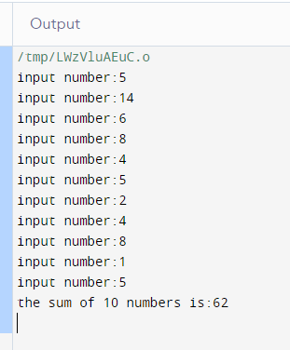

Lab task 2:

#include<iostream>

using namespace std;

int main()

{

int num;

cout<<"enter the number for the table:";

cin>>num;

for(int i=1;i<11;i++){

cout<<num<<"x"<<i<<"="<<num*i<<endl;

}

return 0;

}

OUTPUT:

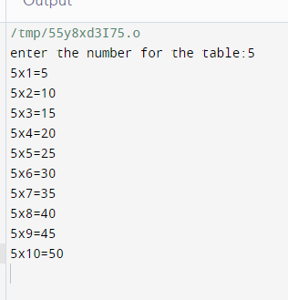

**Lab task 3:**

#include <iostream>

using namespace std;

int main()

{

int number,factorial;

cout<<"enter the number for factorial:";

cin>>number;

factorial=1;

for(int i=1;i<=number;++i){

factorial*=i;

}

cout<<"factorial of"<<number<<"is"<<factorial<<endl;

return 0;

}

**Output:**

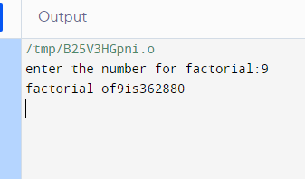

**Lab task 4:**

#include <iostream>

using namespace std;

int main() {

int n;

cout << "Enter the number of terms you want in the Fibonacci sequence: ";

cin >> n;

if (n <= 0) {

cout << "Please enter a positive number." << endl;

return 1;

}

long long first = 0, second = 1, next;

cout << "Fibonacci Sequence up to " << n << " terms: " << endl;

for (int i = 0; i < n; i++) {

if (i <= 1)

next = i;

else {

next = first + second;

first = second;

second = next;

}

cout << next << " ";

}

cout <<endl;

return 0;

}

**Output:**

